Spring Security
It has it own login form by default if not required we can customize or replace with our own customer login page
- The default user name is “user” and get the password from the console log
- For create our custom user name and password
Add following snippet in app.properties file
spring.security.user.name=bless
spring.security.user.password=bless

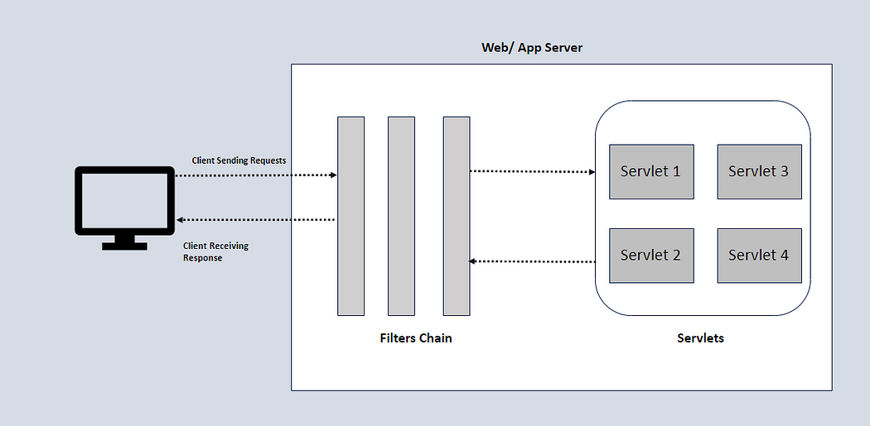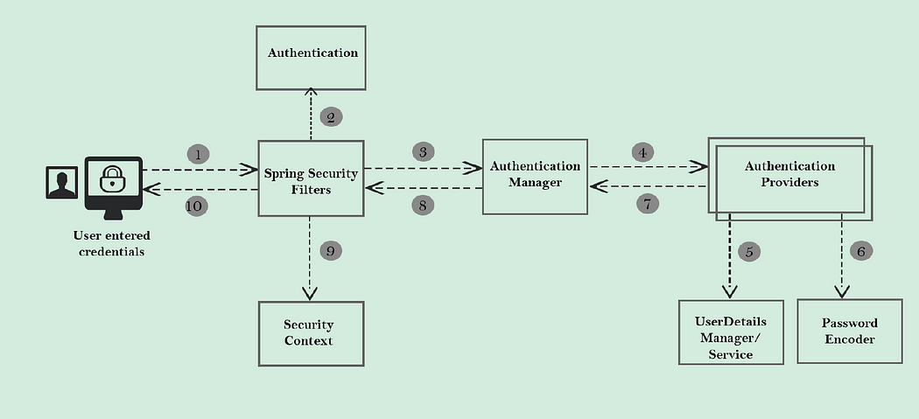

CSRF – cross site request forgery
CSRF token – every time if request come it will generate CRF token update HTTP requests
We have to generate token by using below code
@getMapping(“/Csrf-Token”)
Public CsrfToken getCsrfToken(HttpServletRequest request )
{
Return (CsrfToken)request.getAttribute(“_csrf”)
}

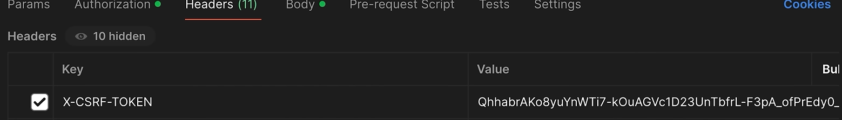

To customize the filter-chains we need the config Class
@Configuration
@EnableWebSecurity
Public Class SecurityConfig {

@Bean
Public SecurityFilterChain SecurityfilterChain(HttpSecurity http)
{

http.csrf(customizer-> customizer.disable());
http.authorizeHttpRequests(request->request. anyRequest().authenticated());
http.formLogin(Customizer.withDefaults());
http.httpBasic(Customizer.withDefaults());
http.sessionManagement(session->session.sessionCreationPolicy(sessionCreationPolicy.STATELESS))

Return http.build();

}

@Bean
Public UserDetailsService userdetailaservice ()
{
UserDetails user1=User.withDefaultPasswordEncoder()
.username(“Bless”).password(“B@123”).roles(“admin”).build();

Return new InMemoryUserDetailsManager(user1);
}

}

build() – will return the Object of SecurityFilterChain

now we customize Authentication provider and create our own userdetailsService used to connect our database

@Configuration
@EnableWebSecurity
Public Class SecurityConfig {

@Bean
Public SecurityFilterChain SecurityfilterChain(HttpSecurity http)
{

http.csrf(customizer-> customizer.disable());
http.authorizeHttpRequests(request->request. anyRequest().authenticated());
http.formLogin(Customizer.withDefaults());
http.httpBasic(Customizer.withDefaults());
http.sessionManagement(session->session.sessionCreationPolicy(sessionCreationPolicy.STATELESS))

Return http.build();

}

@Autowired
MyUserDetailsService myUserService;

@Bean
Public AuthenticationProvider authenticationProvider()
DaoAuthenticationProvider provider = new DaoAuthenticationProvider();
Provider.setPasswordEncoder(NoOpPasswordEndoder.getInstance());
Provider.UserDetailsService(myUserService);
Return
}

Step
Creating Custom UserDetailsService class

Class MyUserDetailsService implements UserDetailsService
{

@Autowired
Private UsersRepo;

@Override
Public UserDetails loadByUsername(String Username) throws UsernameNotFoundException
{
Users user= UsersRepo.findByUsername(Username);
If(user==null)
{
Throw new UserNotFoundExceptiion(“user not found”);
}
Return new MyUserDetaisl(user);
}

Then we need to create our custom UserDetails
So that we can return the object in above overidded method

Class MyUserDetaisl implements UserDetails
{
// override all the methods in interface
Public collection<? Extends GrantedAuthority> getAuthorities(){

Return new SimpleGrantedAuthority(“USER”);
}

Private Users user;
MyUserDetaisl(Users user)
{
This.user=user;
}

}

Spring Security with Spring Boot and JWT
Steps

